Tencor Alpha-Step Profile - EpoThin

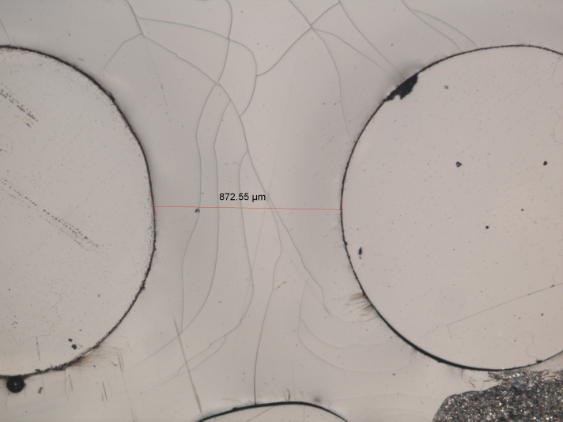

Maximum Depth = 1.5um

