Transoptic
Spectrum Report
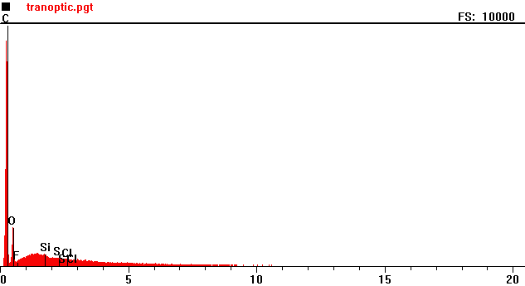
Counts per second
Full scale: 10000 cps
Energy KeV
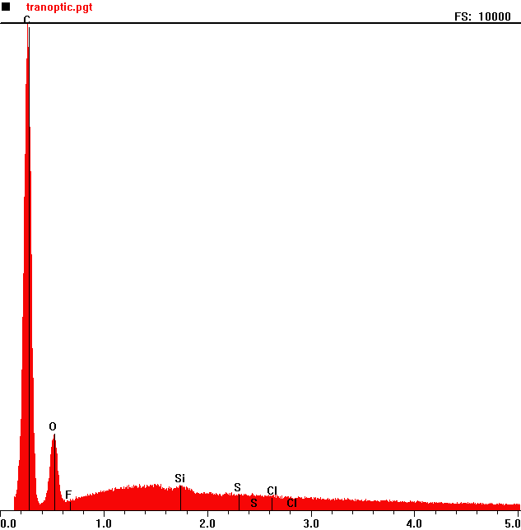
Counts per second
 | Element | Counts per second
C | Carbon | 9925
O | Oxygen | 1549
Si | Silicon | 500

Full scale: 10000 cps
Energy KeV
TransOptic 2
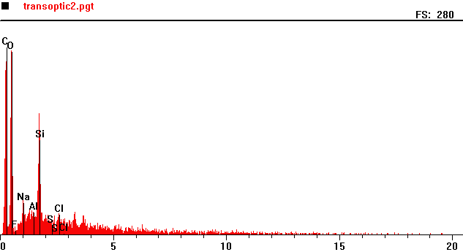
Counts per second
Full scale: 280 cps
Energy KeV
Full scale: 280 cps
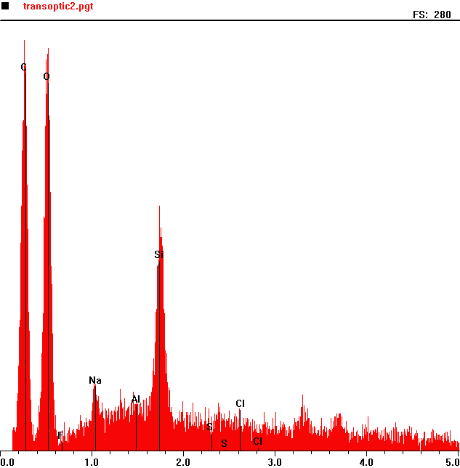
Counts per second
 | Element | Counts per second
C | Carbon | 279
O | Oxygen | 258
Na | Sodium | 43
Cl | Chlorine | 168

Energy KeV

