Specifix
Spectrum Report
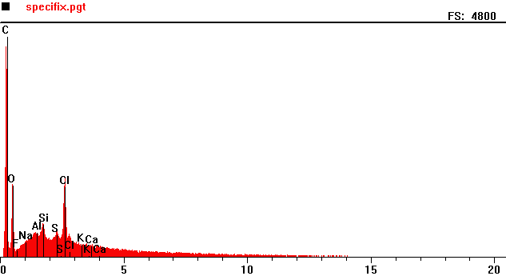
Counts per second
Full scale: 4200 cps
Energy KeV
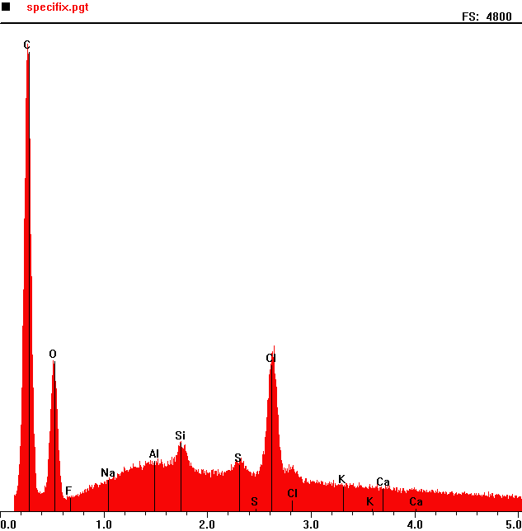
Counts per second
 | Element | Counts per second
C | Carbon | 4526
O | Oxygen | 1480
Si | Silicon | 688
s | Sulphur | 481
Cl | Chlorine | 1530

Energy KeV
Full scale: 4200 cps

