Robnor Resin
Spectrum Report
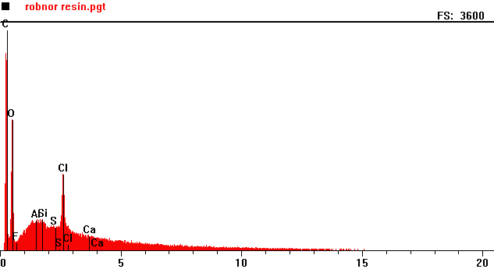
Counts per second
Full scale: 3600 cps
Energy KeV

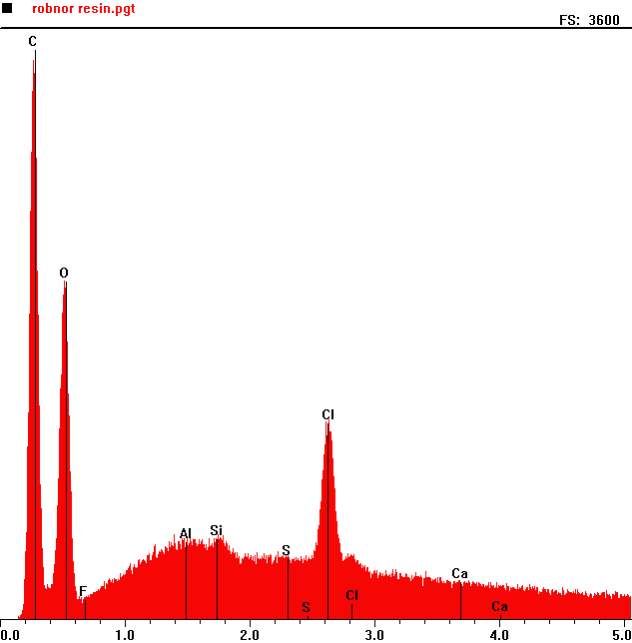
Counts per second
 | Element | Counts per second
C | Carbon | 3473
O | Oxygen | 12060
Si | Silica | 513
Cl | Chlorine | 1149

Full scale: 3600 cps
Energy KeV

