Petropoxy
Spectrum Report
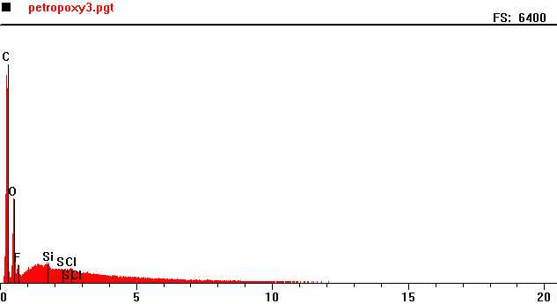
Counts per second
Full scale: 6400 cps
Energy KeV
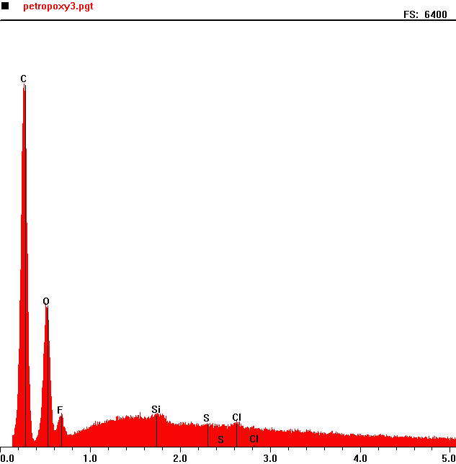
Counts per second
 | Element | Counts per second
C | Carbon | 5443
O | Oxygen | 2079
F | Fluorine | 502
Si | Silica | 498
Cl | Chlorine | 351

Full scale: 6400 cps
Energy KeV

