Korapox 439
Spectrum Report

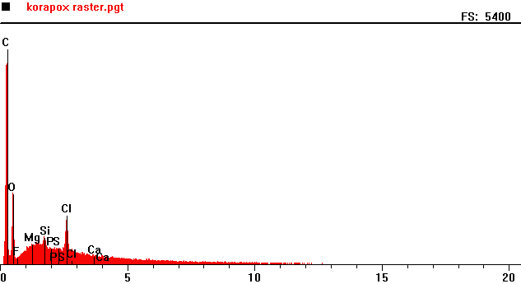
Counts per second
Energy KeV
Full scale: 5400 cps

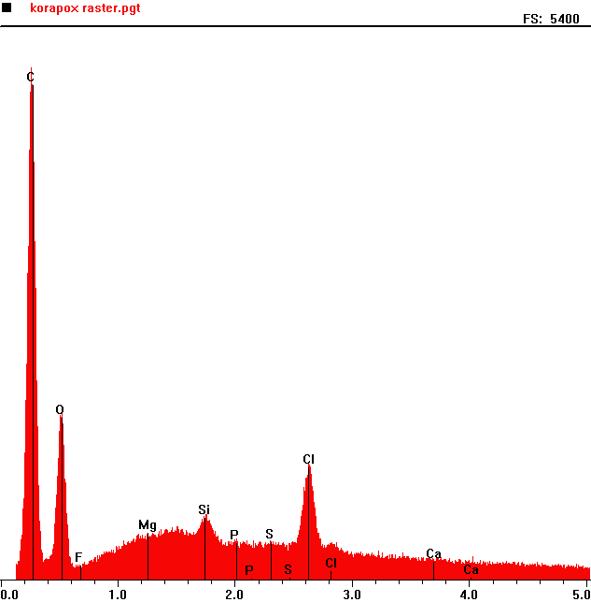
Counts per second
Full scale: 5400 cps
 | Element | Counts per second
C | Carbon | 4882
O | Oxygen | 1584
Si | Silica | 613
Cl | Chlorine | 1106

Energy KeV

