EpoThin
Spectrum Report
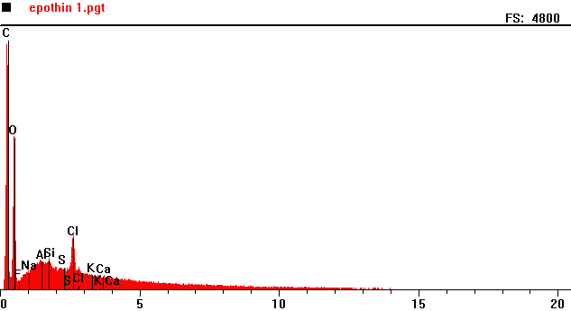
Counts per second
Full scale: 4800 cps
Energy KeV

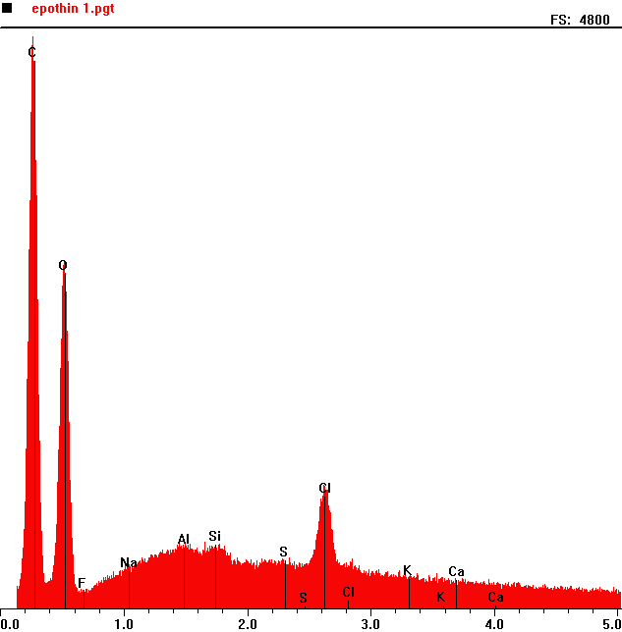
Counts per second
 | Element | Counts per second
C | Carbon | 4722
O | Oxygen | 2865
Cl | Chlorine | 1039

Full scale: 4800 cps
Energy KeV

