Ciba Geigy
Spectrum Report
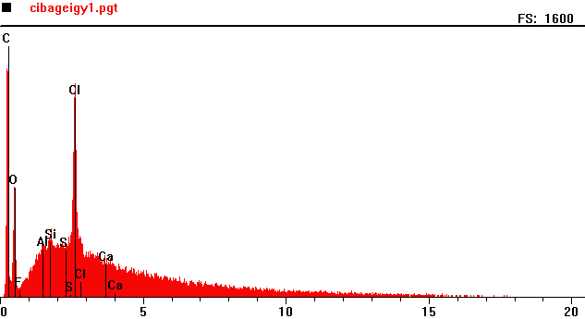
Counts per second
Full scale: 1600 cps
Energy KeV
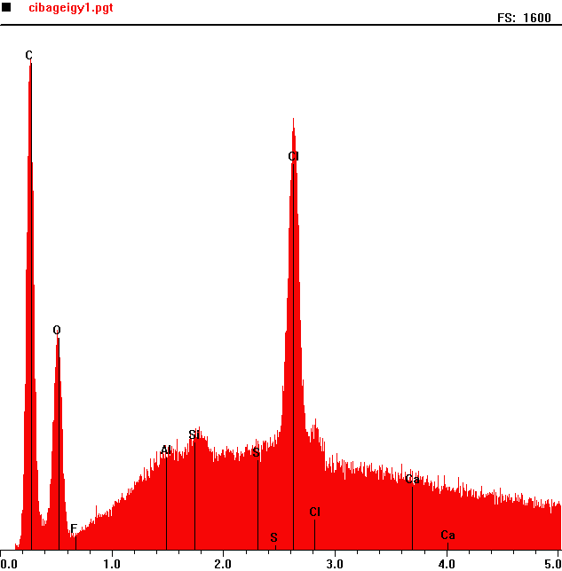
Counts per second
 | Element | Counts per second
C | Carbon | 1498
O | Oxygen | 672
Cl | Chlorine | 1315

Full scale: 1600 cps
Energy KeV

